

End Semester Report

Project Title: University Dashboard using Power BI

**Author:** Surya Deep Das

**Mentor:** Prof. Supratik Banerjee

**Institutional Instructor:** Prof. Debasish Sengupta

**Organization:** NIIT University

**Date:** 30th July, 2023

# **Acknowledgement**

I would like to express my heartfelt gratitude and extend my sincere acknowledgement to Sir Debasish for his exceptional guidance and mentorship. His extensive knowledge and expertise in the field have been instrumental in shaping my understanding and growth. I would also like to thank him for giving me an opportunity to convey and showcase my skills as a teacher for a short period of time to second year students in the university. This has helped me a lot to engage with students and deliver and gain a lot of knowledge.

Secondly, I would like to acknowledge Sir Supratik for his invaluable support and encouragement throughout my journey. His profound insights and unique perspectives have challenged and inspired me to push beyond the limits. His unwavering belief in my abilities has been a constant source of motivation for me.

Lastly, I would like extend my appreciation to the CIC team. They played a pivotal role in upholding the principles of transparency and accountability and their commitment to ensuring access to information has been commendable

In conclusion, I am deeply indebted to Sir Debasish, Sir Supratik, and the CIC for their invaluable contributions, guidance, and support. Their mentorship and expertise have played an instrumental role in shaping my personal and professional development. I am truly grateful for their unwavering support, and I will carry the lessons I have learned from them throughout my life and career.

**Declaration**

I, Surya Deep Das, a student of NIIT UNIVERSITY, hereby declare that the report titled "End Semester Report” submitted by me as a part of Industry Practice: NU 402, is a result of my original work and research. I have diligently conducted the necessary research, analysis, and documentation to produce this report.

I further declare that:

1. The information presented in this report is based on authentic and reliable sources to the best of my knowledge.
2. Any external sources of information, such as books, research papers, websites, or other references, have been duly cited and acknowledged within the report, following the prescribed citation style.
3. This report has not been submitted previously in any form, either to this university or any other educational institution, for academic credit or evaluation.
4. The ideas, concepts, and arguments presented in this report are my own, unless otherwise stated, and do not infringe upon the intellectual property rights of others.
5. Any contributions or assistance received from individuals, such as faculty members, researchers, or colleagues, have been duly acknowledged within the report.
6. I am aware of the university's policies and guidelines regarding academic integrity, plagiarism, and misconduct, and I have adhered to these guidelines throughout the completion of this report.

I understand that any violation of academic integrity, including plagiarism or misrepresentation of work, may result in disciplinary actions, including but not limited to academic penalties, suspension, or expulsion, as determined by the university.

I take full responsibility for the contents of this report and any consequences arising from its submission. I am willing to provide further clarification or evidence to support the originality and authenticity of this work, if required.

Signature:

Name: Surya Deep Das

Date: 30th July, 2023

**Endorsements**

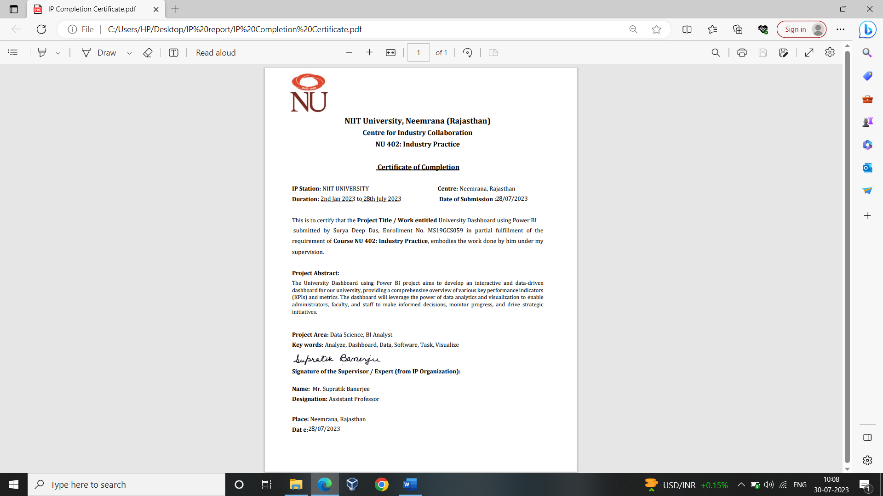

**Abstract**

The University Dashboard project aims to develop an interactive and data-driven dashboard for our university, providing a comprehensive overview of various key performance indicators (KPIs) and metrics. The dashboard will leverage the power of data analytics and visualization to enable administrators, faculty, and staff to make informed decisions, monitor progress, and drive strategic initiatives.

The project report will involve collecting relevant data from multiple student information systems and other databases. This data will be integrated into a centralized repository and transformed into meaningful insights using business intelligence tools such as Power BI. Additionally, the University Dashboard will promote collaboration and transparency by enabling users to share dashboards, reports, and insights with relevant stakeholders. It will provide mobile accessibility, allowing users to access the dashboard on smartphones and tablets, ensuring continuous access to data and analytics.

The University Dashboard will feature interactive visualizations, including charts, graphs, and tables, allowing users to explore and analyze data based on their specific needs. It will provide real-time or near-real-time updates to ensure that stakeholders have access to the most current information.

This project report also discusses about my journey all throughout the semester related to my project work. The project report discusses about how this project enhanced my skills in my engineering field and how I was also offered to teach my skills for a short period of time to a group of junior students (second year) in my own university. This project helped to counter question my knowledge and creativity in my field and also to learn a lot.

**Table of Contents**

|  |  |
| --- | --- |
| **Contents** | **Page Number** |
| Objective | 6 |
| Problem Definition | 6 |
| Scope | 6 |
| About Organization | 6 - 7 |
| Introduction: | 8 |
| Aims of the Project | 8 |
| Analysis of the Problem Statement | 8 |
| Methodology: | 9 - 11 |
| Technical Performances | 9 |
| Timeline | 10 |
| Impact | 10 |
| Customer Focus | 11 |
| Cost Effective Strategies | 11 |
| Discussion | 12 |
| Conclusion | 13 |
| Recommendation | 14 |
| Reference | 15 |
| Appendix | 16 |

**Objective**

The University Dashboard project aims to develop an interactive and data-driven dashboard for our university, providing a comprehensive overview of various key performance indicators (KPIs) and metrics. The dashboard will leverage the power of data analytics and visualization to enable administrators, faculty, and staff to make informed decisions, monitor progress, and drive strategic initiatives.

**Problem Definition**

To develop a university dashboard using Power BI software- This Dashboard should provide effective visualization and provide insights of the student information for analysis.

**Scope**

The Scope can vary depending on the specific objectives, requirements and resources of the institution. The project includes data collection and integration in the software. Then it comes in the process of dashboard design and visualization. Proper planning, stakeholder engagement and continuous communication will be essential to define the scope and ensure successful implementation of the project.

**About Organization**

NIIT, formerly known as the National Institute of Information Technology, is a global skills and talent development company. It was founded in 1981 in India and has since expanded its operations to several countries worldwide.

NIIT University (NU) is a private, not-for-profit institution located in Neemrana, Rajasthan, India. It was established in 2009 as a collaboration between NIIT Limited, a global skills and talent development company, and the Government of Rajasthan. Being a brain child of NIIT, NU aims to create a distinctive educational experience that combines industry-relevant skills with a strong emphasis on research, innovation, and entrepreneurship.

NIIT University has a state-of-the-art campus spread across 100 acres. The campus provides modern infrastructure and facilities including well-equipped classrooms, laboratories, research centers, libraries, sports facilities, hostels, and a Wi-Fi enabled campus. The campus is designed to facilitate a conducive learning and living environment for students.

NIIT University offers undergraduate, postgraduate, and doctoral programs in various disciplines. It offers programs in areas such as Computer Science and Engineering, Electronics and Communications Engineering, Biotechnology, Management, Data Science, Cyber Security, and more. It follows a learner-centric approach to education, combining theoretical knowledge with hands-on experiential learning. The curriculum is designed to be industry-focused, incorporating industry projects, internships, and industry mentorship. The university also emphasizes interdisciplinary learning, research-oriented projects, and the development of critical thinking and problem-solving skills.

NIIT University has collaborated with several partners to enhance its educational programs and provide students with industry-relevant knowledge and skills.

1. Industry Partners: NIIT University has established collaborations with leading industry players to facilitate industry exposure, internships, and placement opportunities for its students. These partners include organizations from various sectors such as IT, finance, consulting, and manufacturing.
2. Academic Partnerships: These partnerships promote student and faculty exchanges, joint research initiatives, curriculum development, and sharing of best practices. Some of the academic partners of NIIT University include international universities and institutions from countries like the United States, Canada, Australia, and the United Kingdom.
3. Technology Partners: NIIT University partners with technology companies to incorporate the latest tools, technologies, and platforms into its academic programs. These collaborations help students gain hands-on experience with cutting-edge technologies and stay updated with industry trends. Some technology partners of NIIT University include Microsoft, SAP, Oracle, and Adobe.
4. Government Partnerships: NIIT University collaborates with government agencies and bodies to align its programs with national skills development initiatives, research funding opportunities, and policy frameworks.

**Introduction**

**Aims of the Project**

1. To develop an interactive data-driven dashboard
2. A comprehensive overview of the student’s performance
3. To access and analyze the relevant data
4. To provide real and non-real time update.

**Analysis of the Problem Statement**

1. Data Sources: The project requires integrating data from multiple sources, such as student information systems, learning management systems, financial systems, and other databases. The availability and quality of these data sources will impact the accuracy and reliability of the insights derived from the dashboard.
2. Tools and Technologies: The project utilize business intelligence tools like Power BI, data integration tools, and potentially cloud-based infrastructure for hosting the dashboard. The choice of tools and technologies should align with the project's objectives, budget, and scalability requirements.
3. Implementation Challenges: Some challenges that may arise during the implementation of the University Dashboard Project include data integration complexities, ensuring data accuracy and consistency, user adoption and training, data security and privacy considerations, and addressing scalability and performance requirements as the volume of data grows.

**Methodology**

**Technical Performances**

1. Data Collection and Integration: This involves gathering data from various sources relevant to the dashboard's purpose. It may include extracting data from databases, APIs, spreadsheets, or other data storage systems. The collected data is then transformed and integrated into a unified format suitable for visualization.
2. Data Cleaning and Preparation: Data obtained from different sources often requires cleaning and preparation to ensure its accuracy and consistency. This involves activities such as removing duplicates, handling missing values, standardizing data formats, and performing necessary data transformations or aggregations.
3. Dashboard Design and Layout: This activity involves designing the overall layout, structure, and visual elements of the dashboard. It includes selecting appropriate visualization types (charts, graphs, maps, tables, etc.) based on the data and insights to be presented. The design should prioritize clarity, usability, and an intuitive user interface.
4. Visualization Development: This activity involves implementing the chosen visualizations using dashboarding or business intelligence tools. It includes configuring the visualizations with the relevant data, applying appropriate formatting, colours, labels, and tooltips to enhance understanding and usability. Interaction features such as filtering, sorting, and drill-down capabilities may also be implemented.
5. Dashboard Interactivity and User Experience: To enhance user experience, interactive features can be added to the dashboard. This includes enabling users to filter data based on specific criteria, drill down into more detailed information, or interact with the visualizations to explore data from different perspectives. User-friendly navigation and intuitive interactions contribute to an engaging dashboard experience.
6. Data Refresh and Automation: For real-time or near-real-time dashboards, data refresh mechanisms should be implemented. This may involve setting up automated data refresh schedules or establishing connections to live data sources. It ensures that the dashboard provides the most up-to-date information without manual intervention.
7. Performance Optimization: As the amount of data and complexity of the dashboard increase, performance optimization becomes crucial. Techniques such as data aggregation, indexing, caching, or query optimization may be applied to ensure fast loading times and smooth user interactions.

**Timeline**

|  |  |  |  |  |  |
| --- | --- | --- | --- | --- | --- |
| February 2023 to June 2023 |  |  |  |  |  |
|  |  |  |  |  |  |
| **Contents** | **February** | **March** | **April** | **May** | **June** |
| Know Your Organization |  |  |  |  |  |
| Understand of the Project |  |  |  |  |  |
| Work Plan |  |  |  |  |  |
| Technical Report Submission |  |  |  |  |  |
| Gaining skills on Software (SQL, Power BI) |  |  |  |  |  |
| CIC group Discussion |  |  |  |  |  |
| Given Raw Data Set |  |  |  |  |  |
| Creating Wireframe Model |  |  |  |  |  |
| Seminar Report Submission |  |  |  |  |  |
| IP Certificate Submission |  |  |  |  |  |
| End Semester Report Submission |  |  |  |  |  |

**Impact**

Performance Monitoring and Evaluation: The Dashboard can enable monitoring and evaluation of various performance indicators, such as student retention, graduation rates, faculty productivity, and research output.

Advanced Analytics and Predictive Modeling: As technology advances, University Dashboards can incorporate advanced analytics techniques and predictive modeling to generate valuable insights.

Integration of IoT and Sensor Data: The Internet of Things (IoT) and sensor technologies can be leveraged to collect real-time data from various sources within the university environment.

**Customer Focus**

1. Enables real time analysis with quick navigation
2. Improves decision making
3. Reports can be accessed across multiple platforms
4. Access to real-time information
5. Personalized dashboards

**Cost Effective Strategies**

1. Open-Source or Cost-Effective Tools: Consider utilizing open-source or cost-effective tools and technologies for developing the University Dashboard. Open-source business intelligence tools like Apache Superset or low-cost options like Microsoft Power BI can provide powerful features and capabilities at a fraction of the cost compared to enterprise-level solutions.
2. Scalable and Modular Design: Build the University Dashboard with a scalable and modular design that allows for future enhancements and additions without significant rework or cost. This approach ensures that the dashboard can grow and adapt to changing requirements and technology advancements, minimizing long-term maintenance and development expenses.
3. Cloud-based Infrastructure: Consider leveraging cloud-based infrastructure, such as Platform-as-a-Service (PaaS) or Software-as-a-Service (SaaS) offerings, for hosting and managing the University Dashboard. Cloud solutions often provide cost advantages through pay-as-you-go models, eliminating the need for significant upfront hardware and infrastructure investments.

**Discussion**

Overall, the University Dashboard Project has the potential to provide significant value to the university by enabling stakeholders to access and analyze data in a user-friendly and visually appealing manner. It empowers informed decision-making, enhances performance monitoring, and fosters a data-driven approach within the university community. However, careful attention should be given to data quality, user training, and ongoing maintenance to ensure the long-term success of the project. These technical activities require expertise in data manipulation, visualization tools, programming languages, data modeling, and user experience design. Collaboration between data analysts, dashboard developers, and domain experts is essential to ensure the technical implementation aligns with the dashboard's intended purpose and meets the stakeholders' needs.

**Conclusion**

When utilizing Power BI to build a University Dashboard, universities can leverage its capabilities to gain insights into student Enrollment, academic performance, financials, research output, and other critical metrics. It empowers decision-makers to track progress, identify trends, and make informed decisions to drive student success and institutional excellence.

It's important to note that building a University Dashboard using Power BI requires data integration, modelling, and visualization expertise. Universities may need to allocate resources or work with professionals skilled in Power BI to effectively implement and maintain the dashboard.

The University Dashboard project will enhance the university's ability to track progress, identify trends, and make informed decisions. It will empower stakeholders to drive student success, optimize resources, and improve institutional effectiveness. The project will contribute to a culture of data-driven decision-making and continuous improvement within the university community.

Also, my project was not been a threshold up to university engagement but a lot with other SQL projects. This helped me a lot in my gaining and learning SQL projects. Also, there were other dashboards which I have made related to other objectives when I have sat for the interview purpose alongside my university project work.

This had been a wonderful journey for me as I have gained a lot of wisdom and knowledge. In the near future I hope every bit is not going to be a waste but will definitely bore fruit for me. Moreover, the classes with the juniors during the month of April was the most excitement part as I was able to convey all the knowledge that I have and it was a valuable outcome for me.

**Recommendation**

Personalized Learning and Adaptive Systems: With the integration of artificial intelligence (AI) and machine learning (ML) algorithms, future University Dashboards can offer personalized learning experiences to students. These dashboards can track individual progress, identify learning gaps, and suggest tailored content and interventions to enhance student outcomes.

Mobile and Cloud-Based Access: University Dashboards of the future can be designed with mobile-first approaches, allowing stakeholders to access information and analytics on-the-go through their smartphones or tablets. Cloud-based infrastructure can enable seamless collaboration and data sharing across different devices and locations.

Integration of Alumni and Employer Data: Future University Dashboards can integrate alumni and employer data to track graduate outcomes, career progression, and industry trends. This information can provide insights into the effectiveness of educational programs, identify areas of skill demand, and foster stronger industry-academia partnerships.

Data Privacy and Security: As data privacy and security become increasingly important, future University Dashboards will need to incorporate robust measures to protect sensitive information. Implementing secure access controls, data encryption, and compliance with privacy regulations will be crucial to maintain stakeholder trust.

# **References**

|  |  |
| --- | --- |
| [1] | MIcrosoft, "Power BI," Microsoft, July 2015. [Online]. Available: https://powerbi.microsoft.com/en-us/. [Accessed July 2015]. |
| [2] | Microsoft Power BI Documentation, "Power BI documentation," [Online]. Available: https://docs.microsoft.com/en-us/power-bi/. |
| [3] | Power BI Desktop Tutorial, "Power BI Desktop Report," [Online]. Available: https://docs.microsoft.com/en-us/power-bi/fundamentals/desktop-tutorial-create-report. |
| [4] | A. F. Macro Russo, The Definitive Guide to DAX: Business Intelligence for Microsoft Power BI, SQL Server Analysis Services, and Excel Second Edition, Torronto: Microsoft, 2022. |
| [5] | B. K. Devin Knight, Microsoft Power BI Quick Start Guide: Build dashboards and visualizations to make your data come to life, Pragmatic Works,: Packt, 2018. |

**Appendix**

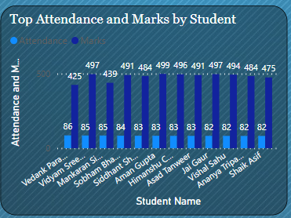 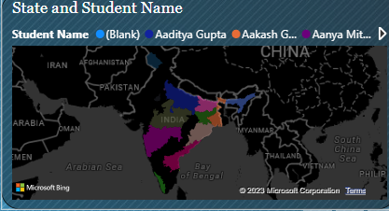

Image (1): Filled Map Image (2): Stacked Column Chart

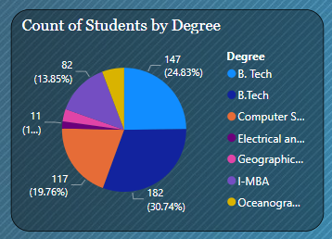 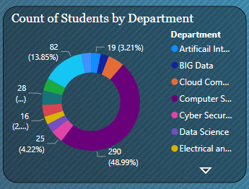

Image (3): Donut Chart Image (4): Pie Chart

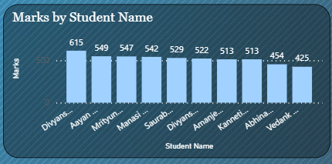

Image (5): Horizontal Bar Graph